УРОК З ТЕМИ «ПОРИ РОКУ І ПОГОДА» У 2 КЛАСІ

**Topic: Seasons of the Year**

Objectives: by the end of the lesson pupils will be able to

* name the months of the year, to describe the seasons,
* ask and answer questions about their favourite seasons using simple structures and appropriate intonation,
* understand oral and written description of the seasons using visual aids;
* pupils will have got practised in operating a pairwork activity, will have improved their confidence as speakers.

Materials/aids: textbooks by Oksana Karpiuk “English. 2”, workbooks, a teacher’s Power Point presentation “Seasons of the year”, a computer, a projector, pictures of the weather, cards with words, tables ( handouts ).

PROCEDURE

I. WARM-UP

1. Teacher greets Ps and proposes them to do a mood forecast. He gives Ps pictures of the sun and the cloud. If Ps have a good mood, they add some sun beams to their sun and if they have a bad mood, add some raindrops to the cloud. Then Ps show their pictures to the teacher and he sums up that most of the Ps have a good mood and are ready to work.

2. Teacher introduces the topic of the lesson and proposes Ps to read the words on the blackboard ( sunny, windy, snowy, frosty, hot, rainy, cloudy, cold ) and match them to the pictures ( Додаток 1, додаток 2 )

3. Teacher asks questions:

What season is it now?

What is the weather like today?

Is it cold today? Is it windy today? Is it cloudy today?

II. PRESENTATION OF NEW MATERIAL

Teacher asks Ps to look at the slides, listen and repeat the names of the months of the year ( teacher’s presentation ):

Winter months: December, January, February.

Spring months: March, April, May.

Summer months: June, July, August.

Autumn months: September, October, November.

III. PRACTICE

1. Find the odd word

Teacher asks Ps to look at the slides ( teacher’s presentation ), read the names of the months, find and say the odd word from the winter, spring, summer and autumn months.

2. Anagrams “What month is it?”

Teacher asks Ps to look at the slides ( teacher’s presentation ) and unscramble the words “May”, “July”, “April”.

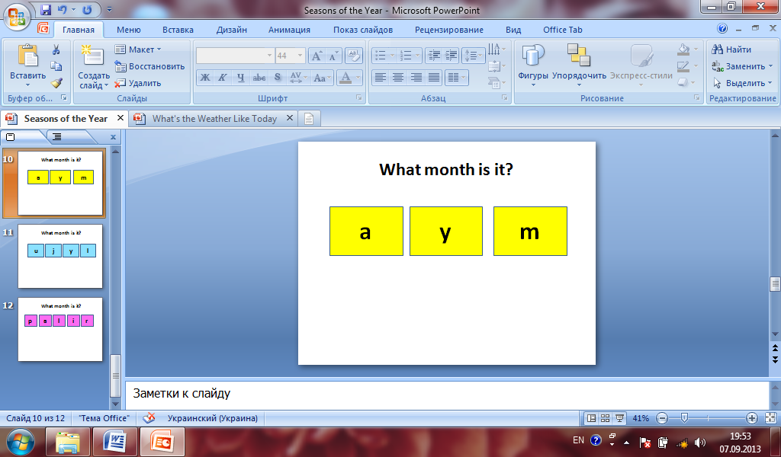 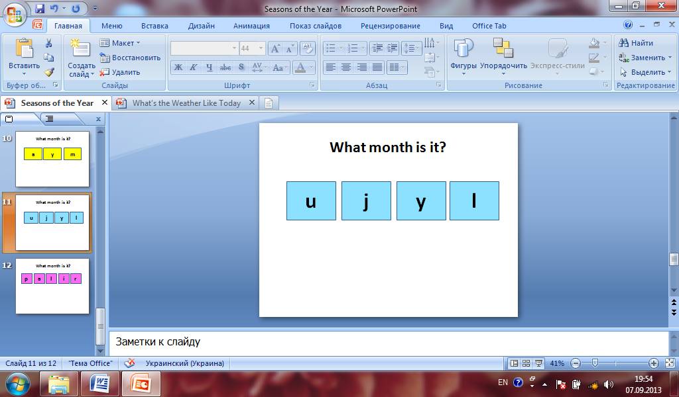 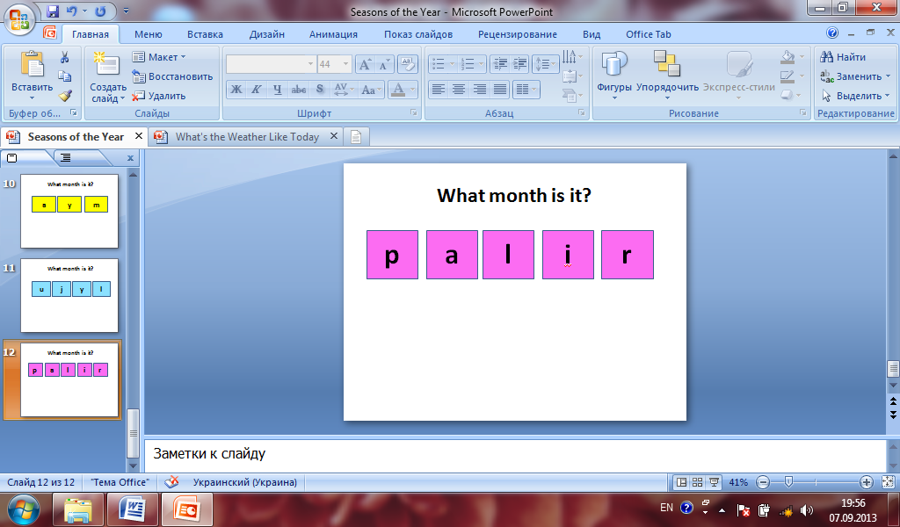

3. Reading

1). Pre-reading activity

Teacher asks Ps:

- What is your favourite season?

Possible answers:

- My favourite season is summer.

- My favourite season is winter.

2). While-reading activity

Teacher proposes Ps to listen to the sentences of exercise 4 at page 121. Ps read the sentences after the teacher all together. Then Ps read again individually:

3). Post-reading activity.

True and false statements ( slide 13, teacher’s presentation )

* Dan’s favourite season is winter.
* It is cold and rainy in winter.
* Dan can play football in winter.
* Dan can make a snowman in winter.

5. Relaxation activity.

Teacher proposes Ps to go for a walk.

I go for a walk,

It is tree,

It is flowers,

It is sun,

It is cloud.

Oh, it is rain.

I'm going to the home!

6. Speaking

Ps work in pairs. They look at the pictures of exercise 2 at page 120, make up dialogues using the words under the pictures.

Dialogue.

* What season is it?
* It is autumn.
* Yes, it is. / No, it is not. Look, it is raining.
* It’s hot in summer. It’s sunny. I can swim.

7. Writing

Ps write down the words into the table ( handouts ).

|  |  |  |  |  |  |  |  |  |  |  |  |  |  |  |  |  |  |  |  |  |  |
| --- | --- | --- | --- | --- | --- | --- | --- | --- | --- | --- | --- | --- | --- | --- | --- | --- | --- | --- | --- | --- | --- |
| |  | | --- | | shorts, warm, hot, boots, ski, fly a kite, swim, a raincoat, frosty, ride a bike, rainy, a jacket |      |  |  |  |  |  | | --- | --- | --- | --- | --- | |  | Spring | Summer | Autumn | Winter | | Weather is… |  |  |  |  | | I wear… |  |  |  |  | | I can… |  |  |  |  | |

IV. SUMMARY

What did you do at the lesson?

What did you like?

V. HOMEWORK

Work on a weather match.

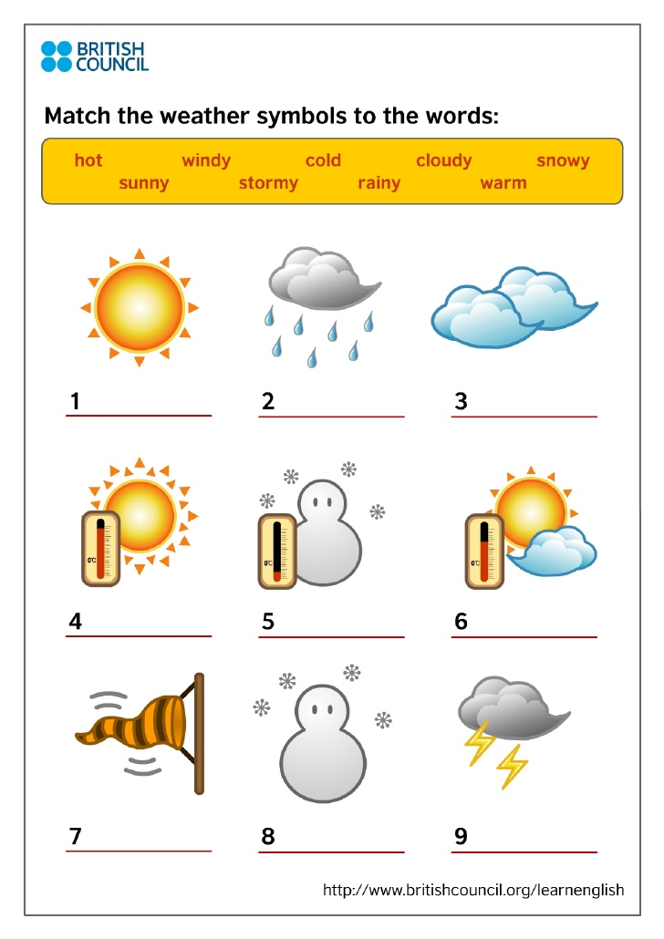

ДОДАТОК 1

|  |  |
| --- | --- |
| http://openclipart.org/image/800px/svg_to_png/18894/sivvus_weather_symbols_4.png | http://school-ppt.3dn.ru/kartinki/solnyshki2/s8.png |
| http://activerain.com/image_store/uploads/8/2/5/1/1/ar132829893711528.jpg | http://www.grammarbank.com/images/weather-vocabulary.jpg |

|  |  |
| --- | --- |
| Анимашки о погоде, солнце, гроза, осень, зима, весна, лето | Smayls.ru | http://www.stihi.ru/pics/2009/11/20/8714.jpg |
| j0251134 | Frozen |

ДОДАТОК 2

|  |  |
| --- | --- |
| rainy | sunny |
| cold | windy |
| cloudy | snowy |
| hot | frosty |